 | I N D U S T R Y A D V I S O R Y B O A R D  M E E T I N G A G E N D A  Florida International University  School of Computing and Information Sciences

Date: April 27th, 2007

Time: 5:00 pm

Location: Motorola, Inc.
8000 W. Sunrise Blvd., Plantation, FL 33322
VIP Conference Room
Teleconf. #: Dial: 877.825.8522, passcode: 0998350
Logistics: Steve Luis, FIU (954) 290-9263
Maureen Burke, MOT (954) 723-3797

Agenda:

1. Chair's Opening Statements
Harald Braun, President and CEO, Siemens Networks, LLC

2. Dean's Report
Dr. Yi Deng, Dean, SCIS

3. Research and Development Highlights
Dr. Tao Li, Assistant Professor, SCIS

4. Student Activities
Irene Polycarpou

5. Board Development and Actions

6. Calendar Synchronization for 2007

7. Chair's Closing Statements

Dinner location to be announced

Directions to Motorola, Inc
8000 W. Sunrise Blvd., Plantation, FL 33322
- Enter the facility at first stop light going east on Sunrise Blvd from University Dr.
- At the security gate show camera your ID and mention meeting with Jaime Borras.
- Park in the lot nearby Bldg. 4, use the 24-hour guard entrance.
- Check in at the security desk for your visitor badge.
- On arrival, pls. call Maureen Burke at 954-723-3797 to be escorted to the VIP Conf. Room.
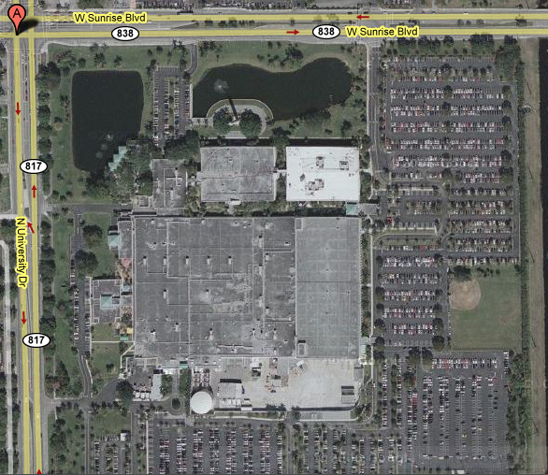
From the South and West take 595 east then University Dr. North
From the North take FL TPK South then Sunrise Blvd West


