 | I N D U S T R Y A D V I S O R Y B O A R D  M E E T I N G A G E N D A  Florida International University  School of Computing and Information Sciences

Date: December 5th, 2008

Time: 5:00 pm

Location: Lennar Corporation
700 NW 107th Ave
Miami, FL 33172
Teleconf. #: Dial: 888-808-6959, Conf. Code: 3355784 followed by “#”
Logistics: Steve Luis, FIU. O: 305-348-6215, C: 954-290-9263
Barbara Antoniazzi, Lennar. O: 305-485-2019

Agenda:

1. Opening Statements
Pete Martinez, Board Chairman, Sr. V.P. Chief Technology & Innovations Officer,
The Quantum Group

2. Dean's Report
Dr. Yi Deng, Dean, School of Computing and Information Sciences (SCIS), FIU

3. Research and Development Highlights
Dr. Raju Rangaswami, Asst. Professor, FIU SCIS

4. Student Activities
Dr. Christine Lisetti, Assoc. Professor, FIU SCIS
Kip Irvine, Instructor, FIU SCIS

5. Board Development and Actions

6. Calendar Synchronization

7. Closing Statements
Pete Martinez, Board Chairman, V.P. Chief Technology & Innovations Officer,
The Quantum Group

Dinner to follow meeting
Directions to:
Lennar Corporation
700 NW 107th Ave
Miami, FL 33172

- Take Turnpike or I-95 to 826 Dolphin Expressway.
- Exit South on 107th ave, enter Lennar Corp. from East entrance on 107th ave.
- Park in either the lots to your left or right and enter the building which faces 107th ave.
- Go to the 4th floor and ask the receptionist for Barbara Antoniazzi. She will escort you to the Wow Pavilion on the 2nd floor where the meeting will be held.

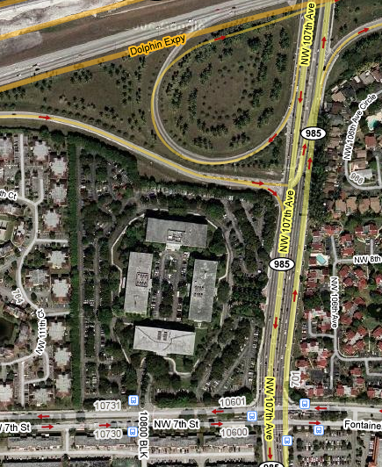

Dinner:

Los Ranchos
125 SW 107th Ave
Miami, FL 33174
305-552-6767

http://www.beststeakinmiami.com/

