 | I N D U S T R Y A D V I S O R Y B O A R D  M E E T I N G A G E N D A  Florida International University  School of Computing and Information Sciences

Date: December 9th, 2005
Time: Friday, 5pm
Location: Ultimate Software
2000 Ultimate Way, Weston, FL 33326
Telephony: Voice Conference number: 305-348-1003
Logistics: Steve Luis, CIS IT/Business Relations (954) 290-9263

Meeting Focus:
Realizing partnerships between academia and industry to support South Florida’s IT ecosystem.

Agenda:

1. Chair's Opening Statements
Harald Braun, President, Siemens Carrier Networks

2. Host Company Presentation
Dr. Roy Gerber, Vice President and CTO, Ultimate Software

3. Dean's Report
Dr. Yi Deng, Dean, School of Computing and Information Sciences, FIU

4. Latin American Grid (LA Grid) Update
Pete Martinez, Vice President, Business Consulting Services and
Senior Location Executive IBM Boca Raton

5. Board Development and Actions
a. Old business
b. New business

6. Calendar Synchronization for 2006

7. Chair's Closing Statements

Dinner to follow at East City Grill, Weston, FL
Directions to Ultimate Software

Address:

2000 Ultimate Way, Weston, FL 33326

- Take I-75 to Arvida Parkway in Weston, which only goes West.
- At the 4th light, turn right onto Town Center Blvd. (to the left, the same street is Weston Hills Blvd.)
- Turn right onto Town Center Circle, which is the first street.
- Turn right into Ultimate Software.
- Meet in the atrium of 2000 Ultimate Way (the larger building). Board members will be escorted to meeting room in building # 2002.
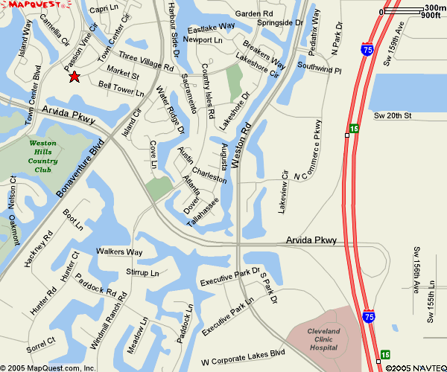

Dinner: East City Grill
Address: 1800 Bell Tower Lane Weston, FL 33326
Phone: 954.659.3339
Website: http://www.eastcitygrill.com



